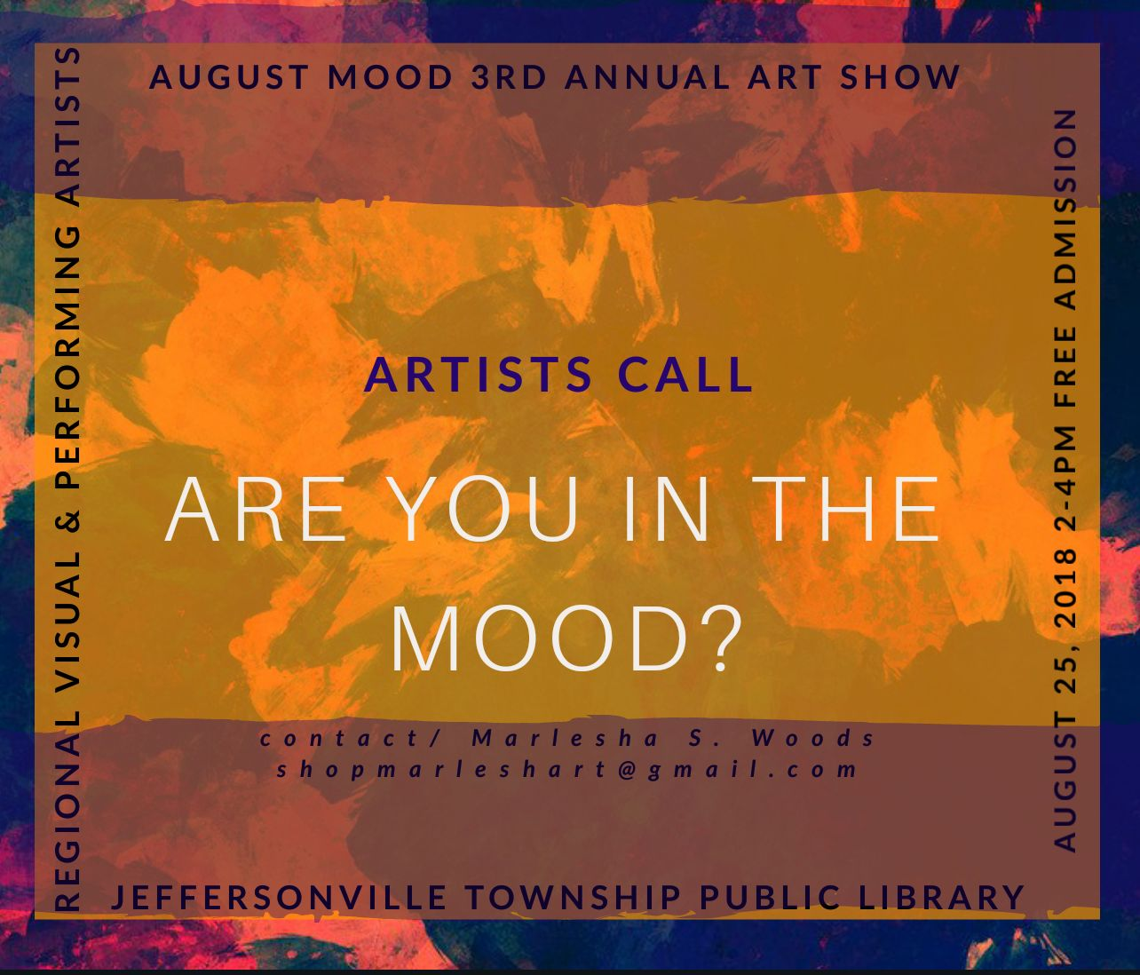

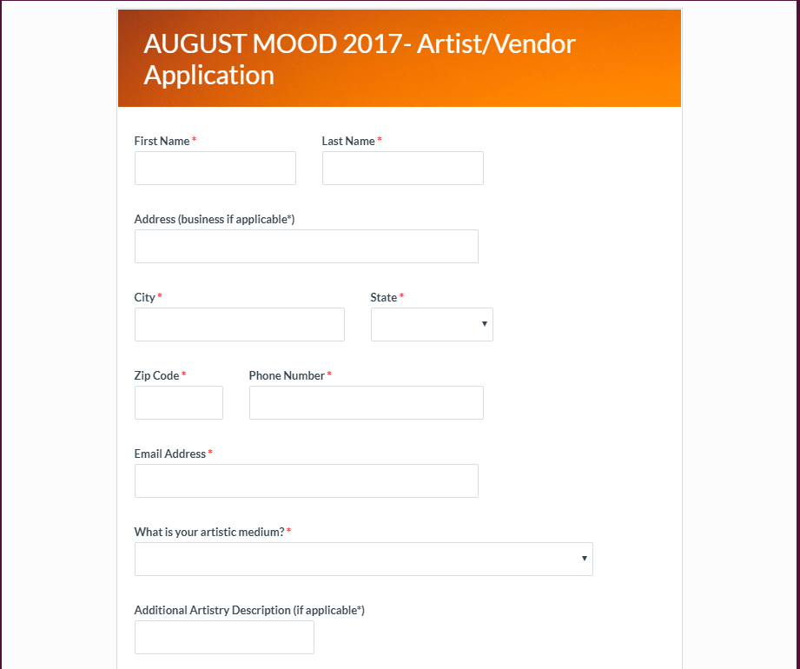

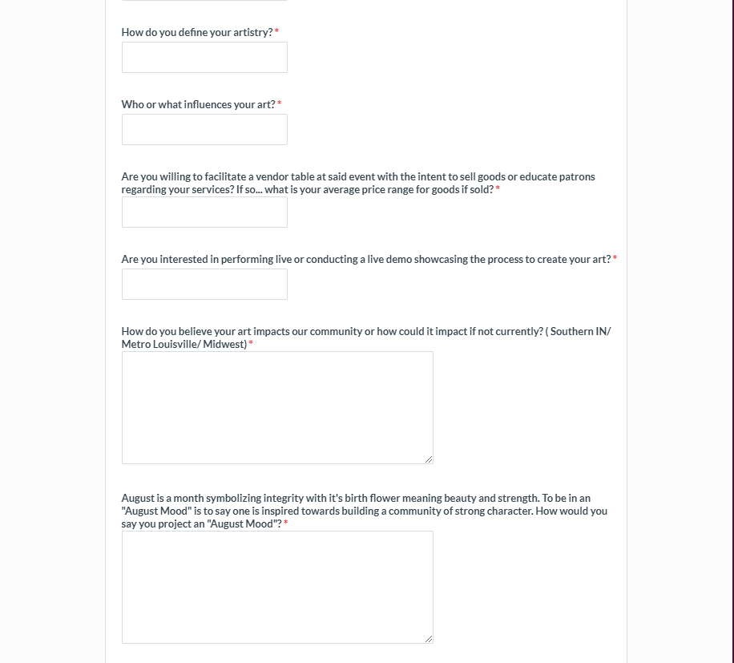

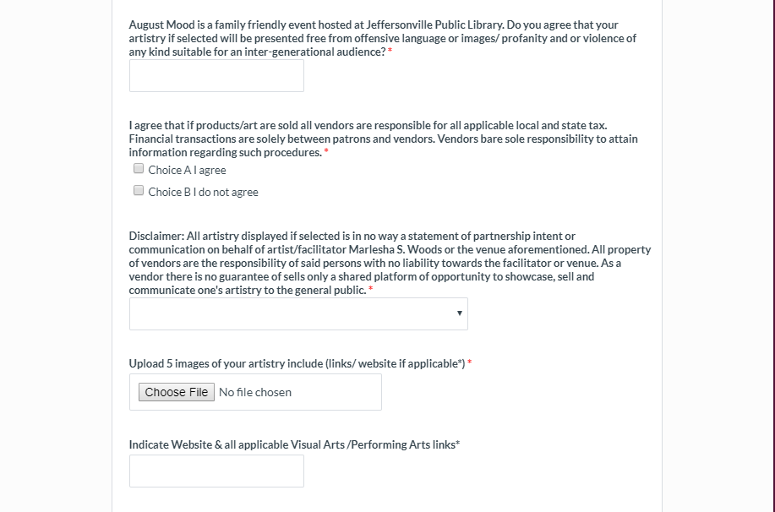

Insert Full Name

Please email all completed artist registration forms & 5 images (jpg.) or videos for performing artists to email [shopmarleshart@gmail.com](mailto:shopmarleshart@gmail.com) by deadline July 25th 11:59pm.

**Thanks for connecting with August Mood!**